Practical 1

Python Basic

1. Read two integers from input keyboard and print three lines where:

The first line contains the sum of the two numbers.  
The second line contains the difference of the two numbers (first - second).  
The third line contains the product of the two numbers.

Sample output:



1. Given an integer n, perform the following conditional actions:

















1. Consider a list (list = []). You can perform the following commands:

insert i e: Insert integer e at position i.  
print: Print the list.  
remove e: Delete the first occurrence of integer e.  
append e: Insert integer e at the end of the list.  
sort: Sort the list.  
pop: Pop the last element from the list.  
reverse: Reverse the list

Given the sample output:

|  |
| --- |
| Enter the number of steps: 12  Enter command: insert 0 5 Enter command: insert 1 10 Enter command: insert 0 6 Enter command: print  [6, 5, 10]  Enter command: remove 6 Enter command: append 9 Enter command: append 1 Enter command: sort  Enter command: print [1, 5, 9, 10]  Enter command: pop Enter command: reverse Enter command: print  [9, 5, 1] |

Given the following codes. Complete the program according to the question.



***Challenge***

1. Morse code is a code where each letter of the English alphabet and each digit are represented by a series of dots and dashes. The table below shows part of the code. Write a program that asks the user to enter a string with only alphanumeric characters, and then converts that string to Morse code.

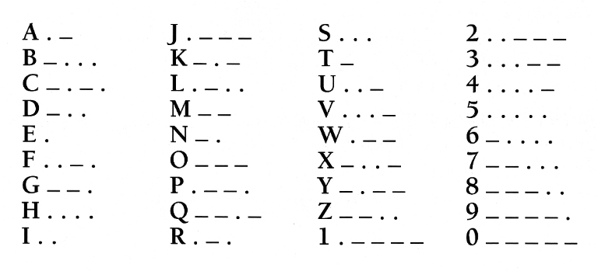

Hint: Which data structures should you use to map a character to a unique Morse code?

***-End-***